A1316-AM,S-Peru-Paracas-Figurine-Terracotta-800-100 BCE

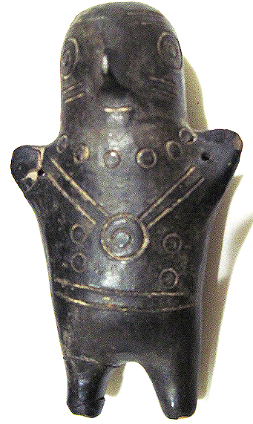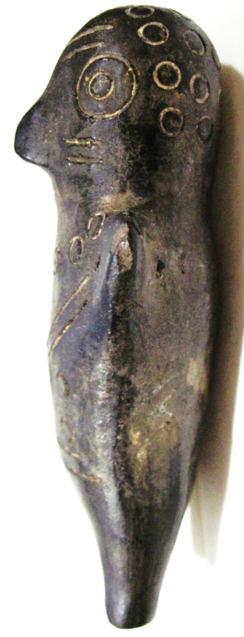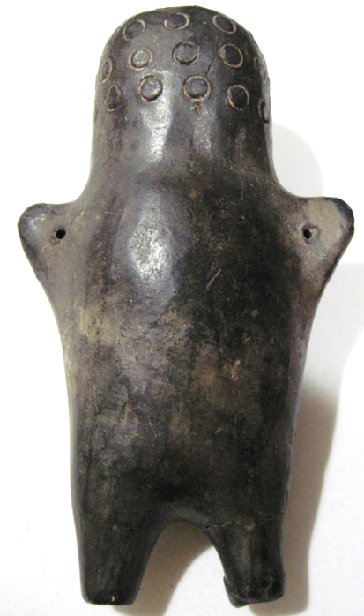

Figs. 1-3. Peru-Paracas-Figurine-Terracotta-800-100 BCE

**Case no.: 9**

**Accession Number: A1316**

**Formal Label:** Peru-Paracas-Figurine-Terracotta-800-100 BCE

**Display Description:**

The Paracas culture (800-100 BCE) on its eponymous peninsula in Peru’s Ica Region is noted for its shaft tombs dug into the Cerro Colorado, which are multiple re-burials and suggests that they were associated with related family members. The present figurine was probably one of the many artifacts deposited in memory of the deceased, in this case probably a child, due to its doll-like qualities. One can also see the presence of a necklace indicated by a ring of circles and a gorget hung from the shoulders. The body also has circular adornments which may indicate a textile design, since textile manufacturing attained a high degree of proficiency among the Paracas people. Paracas textiles included many complex weave structures as well as elaborate plaiting and knotting techniques (Paul 1990).

**LC Classification:** F3429.1.P25

**Date or Time Horizon:** 800-100 BCE

**Geographical Area:** Paracas Peninsula

**Map:**

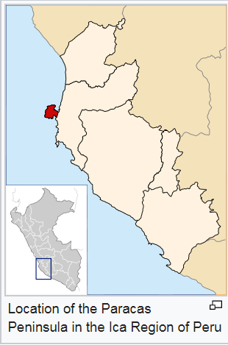

**GPS coordinates:** 13°42′45.12″S 76°12′28.56″W

**Cultural Affiliation:** Paracas Culture

**Medium: black, burnished ceramic**

**Dimensions:** H 10.5 cm, 4 in

**Weight:**

**Condition: original**

**Provenance:** old South American collection.

**Discussion:**

Textile-wrapped, single-body, seated mortuary bundles contain intricate woven textiles similar to the early Nazca and are some of the finest ever produced by Pre-Columbian Andean societies. This figurine may have been associated with such a mortuary bundle.

**References:**

Paul, Anne. 1990. *Paracas ritual attire: symbols of authority in ancient Peru*. The civilization of the American Indian series, vol. 195. Norman: University of Oklahoma Press.

Paul, Anne. 1991. *Paracas Art and Architecture: Object and Context in South Coastal Peru*. Iowa City: University Of Iowa Press.